TASK1 :
import java.io.*;
import java.util.*;
interface PerformOperation {
boolean check(int a);
}
class MyMath {
public static boolean checker(PerformOperation p, int num) {
return p.check(num);
}
PerformOperation isOdd() {
return (int a) -> (a % 2 != 0);
}

PerformOperation isPrime() {
return (int a) -> {
if (a < 2)
return false;
for (int i = 2; i <= Math.sqrt(a); i++) {
if (a % i == 0)
return false;
}
return true;
};
}

PerformOperation isPalindrome() {
return (int a) -> {
int original = a;
int reverse = 0;

while (a > 0) {
reverse = reverse * 10 + a % 10;
a /= 10;
}

return original == reverse;
};
}
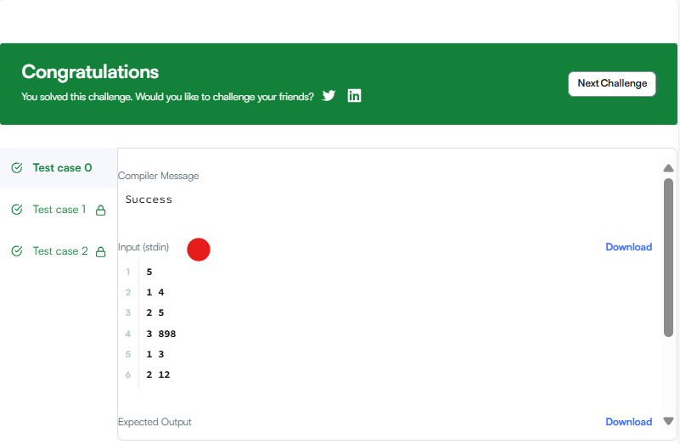
Task 2:
import java.util.*;

class Student {
private int id;
private String fname;
private double cgpa;

public Student(int id, String fname, double cgpa) {
this.id = id;
this.fname = fname;
this.cgpa = cgpa;
}

public int getId() {
return id;
}

public String getFname() {
return fname;
}

public double getCgpa() {
return cgpa;
}
}

public class Solution {
public static void main(String[] args) {
Scanner in = new Scanner(System.in);

int testCases = Integer.parseInt(in.nextLine());

List<Student> studentList = new ArrayList<Student>();

while (testCases > 0) {
int id = in.nextInt();
String fname = in.next();
double cgpa = in.nextDouble();

Student st = new Student(id, fname, cgpa);
studentList.add(st);

testCases--;
}

// Sort students
Collections.sort(studentList, new Comparator<Student>() {
@Override
public int compare(Student s1, Student s2) {

// CGPA: decreasing order
if (s1.getCgpa() < s2.getCgpa()) {
return 1;
} else if (s1.getCgpa() > s2.getCgpa()) {
return -1;
}

// Name: alphabetical order
int nameCompare = s1.getFname().compareTo(s2.getFname());

if (nameCompare != 0) {
return nameCompare;
}

// ID: increasing order
return Integer.compare(s1.getId(), s2.getId());
}
});

// Print sorted names
for (Student st : studentList) {
System.out.println(st.getFname());
}
}
}
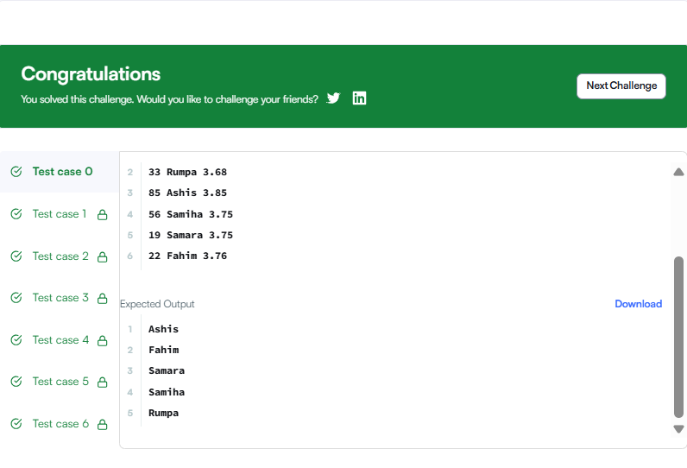
task 3:

class Solution {
public int[] sortArrayByParity(int[] nums) {

int left = 0;
int right = nums.length - 1;

while (left < right) {

if (nums[left] % 2 > nums[right] % 2) {
int temp = nums[left];
nums[left] = nums[right];
nums[right] = temp;
}

if (nums[left] % 2 == 0) {
left++;
}

if (nums[right] % 2 == 1) {
right--;
}
}

return nums;
}
}

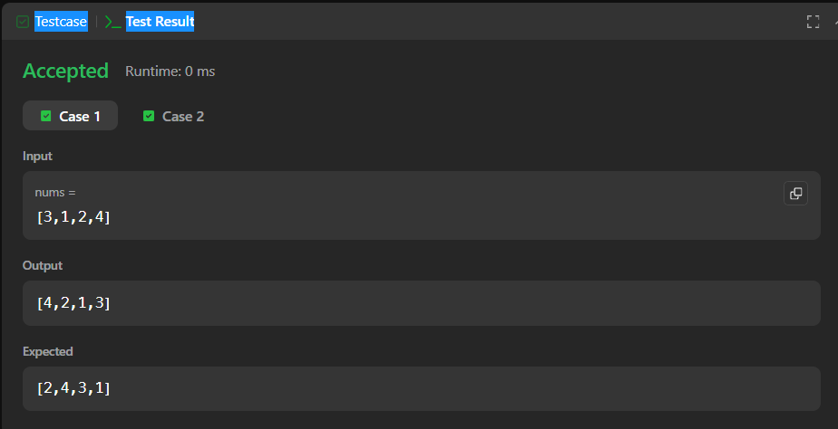
task 4:
import java.util.*;

class Player {
String name;
int score;

Player(String name, int score) {
this.name = name;
this.score = score;
}
}

class Checker implements Comparator<Player> {

@Override
public int compare(Player a, Player b) {

// Sort by score in descending order
if (a.score != b.score) {
return b.score - a.score;
}

// If scores are same, sort by name alphabetically
return a.name.compareTo(b.name);
}
}

public class Solution {
public static void main(String[] args) {

Scanner scan = new Scanner(System.in);

int n = scan.nextInt();

Player[] players = new Player[n];

for (int i = 0; i < n; i++) {
String name = scan.next();
int score = scan.nextInt();

players[i] = new Player(name, score);
}

Checker checker = new Checker();

Arrays.sort(players, checker);

for (int i = 0; i < players.length; i++) {
System.out.println(players[i].name + " " + players[i].score);
}

scan.close();
}
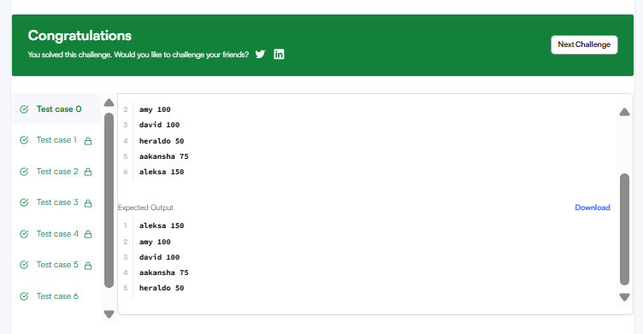
}

Task 5:
import java.util.*;

// Write your Checker class here
class Checker implements Comparator<Player> {

public int compare(Player a, Player b) {

// Higher score first
if (a.score != b.score) {
return b.score - a.score;
}

// If scores are equal, alphabetical order
return a.name.compareTo(b.name);
}
}
class Player{
String name;
int score;

Player(String name, int score){
this.name = name;
this.score = score;
}
}

class Solution {

public static void main(String[] args) {
Scanner scan = new Scanner(System.in);
int n = scan.nextInt();

Player[] player = new Player[n];
Checker checker = new Checker();

for(int i = 0; i < n; i++){
player[i] = new Player(scan.next(), scan.nextInt());
}
scan.close();

Arrays.sort(player, checker);
for(int i = 0; i < player.length; i++){
System.out.printf("%s %s\n", player[i].name, player[i].score);
}
}
}
}
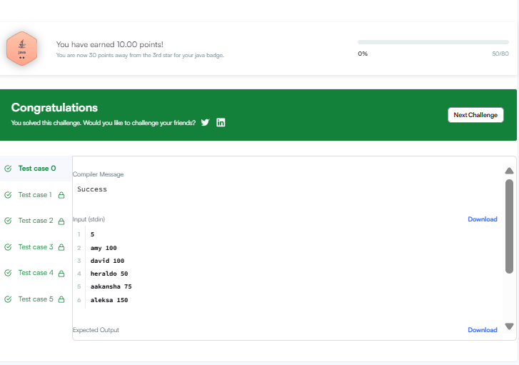
task 6:

class Solution {
public int[] runningSum(int[] nums) {

for (int i = 1; i < nums.length; i++) {
nums[i] = nums[i - 1] + nums[i];
}

return nums;
}
}

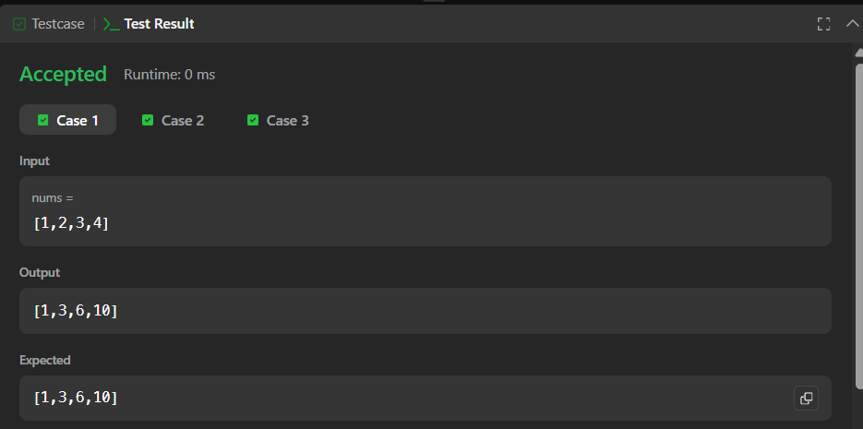
task 7:
class Solution {
public int maximumWealth(int[][] accounts) {

int maxWealth = 0;

for (int i = 0; i < accounts.length; i++) {

int sum = 0;

for (int j = 0; j < accounts[i].length; j++) {
sum = sum + accounts[i][j];
}

if (sum > maxWealth) {
maxWealth = sum;
}
}

return maxWealth;
}
}
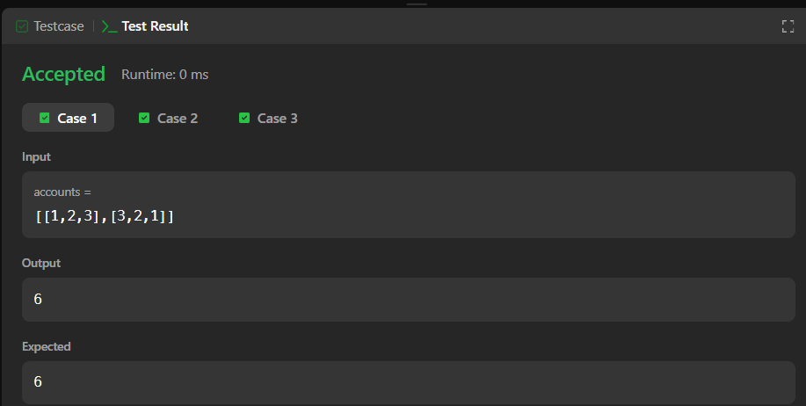
task 8:
class Solution {
public int[] sortedSquares(int[] nums) {

int n = nums.length;
int[] result = new int[n];

int left = 0;
int right = n - 1;

for (int i = n - 1; i >= 0; i--) {

if (Math.abs(nums[left]) > Math.abs(nums[right])) {
result[i] = nums[left] * nums[left];
left++;
} else {
result[i] = nums[right] * nums[right];
right--;
}
}

return result;
}
}
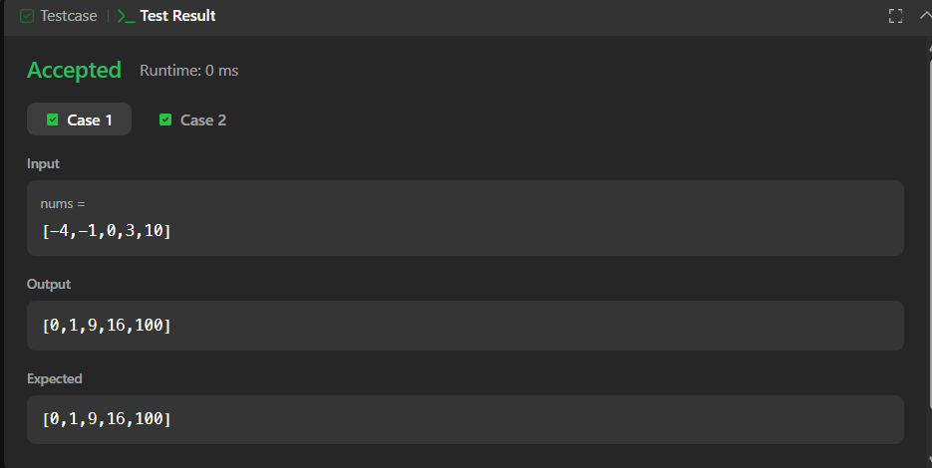
task 9:
class Solution {
public int pivotIndex(int[] nums) {

int totalSum = 0;

// Find total sum
for (int num : nums) {
totalSum += num;
}

int leftSum = 0;

for (int i = 0; i < nums.length; i++) {

// Right sum = total - left - current element
int rightSum = totalSum - leftSum - nums[i];

if (leftSum == rightSum) {
return i;
}

// Add current element to left sum
leftSum += nums[i];
}

return -1;
}S
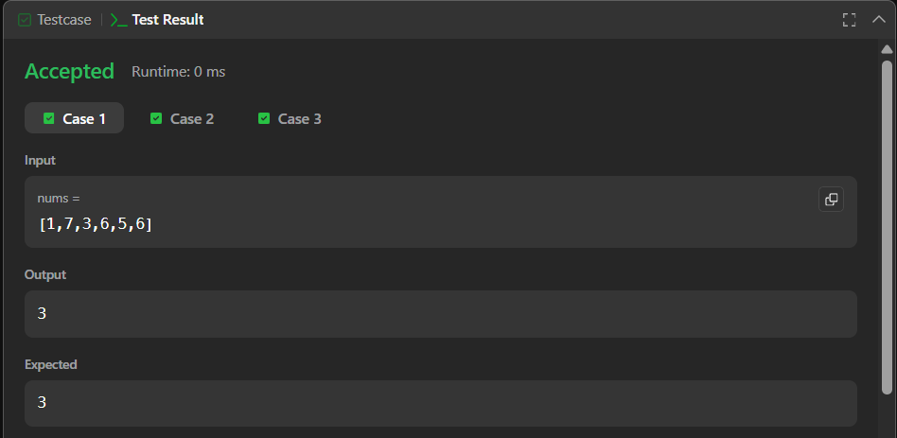
}S

